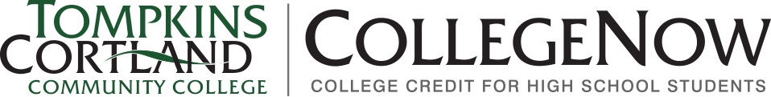

Professional Development Report
Faculty should use this report to document any professional development that occurs outside of the CollegeNow Conference Day. All CollegeNow instructors are required to receive College-approved professional development that supports them and the quality of CollegeNow courses. Please return the completed form to CollegeNow. If you provided a group professional development, prepare one copy of this form and attach a list of the instructors.

CollegeNow Instructor:
High School:
Discipline or Course:
Date(s):
Format: Email / Phone / Video Call / Brightspace / Campus Meeting / School Visit (circle all that apply)
Faculty:
DESCRIBE THE PROFESSIONAL DEVELOPMENT (PROVIDE SEPARATE MATERIALS, AS NEEDED):

Ideas include: sharing content from past CollegeNow workshops, discussing new developments or research, sharing a video or article and discussing it, showing how OER can be used, team-teaching a class, discussing how the instructor is assessing and grading, conducting grade norming activities, hosting the instructor in your class with a reflection on what they saw, sharing strategies for difficult to teach topics, etc.

