
Tompkins Cortland Community College Section Syllabus

Course No. (Credit Hours): ex. MATH120 (4 credits)

Course Title: Use the Tompkins Cortland Community College course title (ex. College Algebra)

Instructor: Even if multiple instructors teach the same course, submit a section syllabus for each.

Contact Information: How students would reach you for help

Location: List your High School or BOCES

Semester: Fall or Spring or Full Year (Most courses should be single semester. If the high school course is full year, but most college content is taught in the spring, select “Spring”)

Course Description: Copy the description from the College Master Course Syllabus. Include any SUNY General Education requirements met. You may add more to the description, but do not take away.

Prerequisites & Basic Skills: Identify all prerequisites (minimum course grades, exam scores, or GPA) and basic skills requirements (IE, writing, reading, writing, or computer skills) used to identify who may register for credit. These should be consistent with the Master Course Syllabus and any other guidelines provided by CollegeNow and your liaison. Include any pre- or co-requisite high school or college courses, grades, or test scores that a student needs in order to register for college credit.

Include the grade level of students; some courses are limited to 12th or 11-12th grade.

For sequential courses, the equivalent of a C or higher is required in the prior course in that discipline; IE, a “C” in ENGL101 to take ENGL102 or “C” in MATH120 to take MATH200 or MATH138. For courses that register in the spring, students should have earned at least a “C” in the fall semester of the high school course in order to register for credit.

Student Learning Outcomes: List the learning outcomes for the course from the College Master Course Syllabus. Some departments may allow you to add to these.

Texts and Materials: Include print, digital, and audiovisual materials. The Master Course Syllabus and sample section syllabi provide suggestions of college-level materials; any texts you select that are not listed must be approved by the faculty liaison. Some courses have specific required textbooks and labs, which will be noted in the guidelines provided by CollegeNow and your liaison.

Class Modalities/Learning Strategies: Briefly describe the teaching methods you intend to use during the course, i.e., lecture, discussion, audio-visual aids, labs, field trips, clinicals, etc. If applicable, indicate how any online learning management systems (Brightspace, Google Classroom, etc.) are being used in the class (as a repository for course materials, discussions, quizzes, and assignment submission). If applicable, indicate whether any students may be participating via synchronous distance learning.

Course Content: Include a listing by either week or class session of the respective topic(s) that will be covered during that time frame. Include any particular readings or homework assignments required each week. Make a note for students that the dates are subject to change.

Required Readings, Presentations, Assignments, etc.: Provide an explanation of each of the requirements for the course (i.e., homework assignments, essays, projects, quizzes, exams, class participation, online discussion posts, presentations, etc.). For each particular requirement, please detail your expectations.

Evaluation/Grading System: Summarize how the final grade is determined using a point and/or percentage system that shows the respective weighting of each of the graded course requirements. The College grade must be calculated by a methodology consistent with the Master Course Syllabus and your faculty liaison’s guidelines. (If the high school grade is calculated differently, indicate how.)

Instructors must use the following grading scale for converting between numerical and letter grades, unless your liaison has provided you with a different scale.

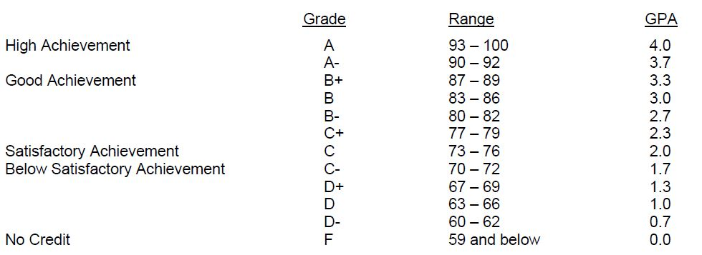

Make-Up Policy/Late Work: Provide your policy for submission of any late work and whether you allow make-up examinations, with or without penalty, and under what circumstances.

Attendance Policy: Provide your policy on attendance, especially in regards to how it may affect the student’s grade or ability to earn college credit for the course. College Attendance Policy to use/apply:

To maintain good grades, regular attendance in class is necessary. Absence from class is considered a serious matter and absence never excuses a student from class work. Unless otherwise provided for by the instructor, all students are expected to promptly attend, on time, every class session for they are registered. If absence is anticipated, it is the student’s responsibility to inform the instructor as far in advance as possible. If a student is absent on the day of an exam or deadline, the instructor will decide whether the exam or assignment may be submitted late. In all cases, it is the student’s responsibility to find out what happened in class. Students are not penalized if they are unable to attend classes because of religious beliefs; students should discuss such absences in advance with their instructors.

Student Responsibilities: Your expectations about the involvement of students in the learning experience and classroom citizenship should be positively and specifically stated here. Be clear about how the expectations may differ from high school in relation to classroom discourse, assignments, role of student vs instructor, how to seek help from you, etc.

Statement of Academic Integrity: Identify your policies and procedures and clearly delineate how you address first time and subsequent academic infractions within your course (including, but not limited to, reduction in grade, elimination of grade, failure for the course). (Misuse of a source is not considered plagiarism, though you may still issue grading penalties.)

Please make explicit note of whether you allow Artificial Intelligence (AI, such as chatGPT) in your classes and your approach to detecting AI work. You may consider adding a statement like the following: “Use of AI is not allowed for work in this class. If I suspect that a student has plagiarized or used AI to generate work, then I reserve the right to orally quiz students on the process they followed for their work to ensure that the work performed is their own. Students who fail to show an understanding of the material and/or fail to show the process followed for assignments, may face grade-related penalties in accordance with the class’s academic integrity policy.” Other options for syllabus language (provided by the University of Minnesota): https://provost.umn.edu/chatgpt-syllabus-statements

Refer to the College’s statement of academic integrity (copied below) and the policy for violations.

Tompkins Cortland Community College’s Statement of Academic Integrity
Every student at Tompkins Cortland Community College is expected to act in an academically honest fashion in all aspects of his or her academic work: in writing papers and reports, in taking examinations, in performing laboratory experiments and reporting the results, in clinical and cooperative learning experiences, and in attending to paperwork such as registration forms.

Any written work submitted by a student must be his or her own. If the student uses the words or ideas of someone else, he or she must cite the source by such means as a footnote. Our guiding principle is that any honest evaluation of a student's performance must be based on that student's work. Any action taken by a student that would result in misrepresentation of someone else's work or actions as the student's own — such as cheating on a test, submitting for credit a paper written by another person, or forging an advisor's signature — is intellectually dishonest and may result in sanctions and/or penalties.

Additional Resource Assistance: Identify academic resources available in school (library, etc.), as well as how students can get instructor help outside of class (office hours or email). You must include that:

Campus and online tutoring resources, as well as study skills assistance, are at https://www.tompkinscortland.edu/library.

Appropriate Academic Adjustments:
Required language, though you may add to it if your school has an additional process:

It is the College’s policy to provide, on an individual basis, appropriate academic adjustments for students with disabilities that may affect their ability to fully participate in college course activities or to meet course requirements. Students with disabilities should contact TC3’s Baker Center for Learning at 607-844-8222 (ext. 4415) or bcl@tompkinscortland.edu to discuss their particular need for appropriate academic adjustments.

Include the following and direct students to our website for guidance and resources:

Tompkins Cortland Community College Expectations and Resources
Students and families should review the guidelines provided on CollegeNow’s website for information on College expectations and policies, implications for academic standing and financial aid, accessing learning resources and services, and transferring college credits. Student Resource links appear on the right side of the CollegeNow homepage at www.tompkinscortland.edu/academics/collegenow

